1.
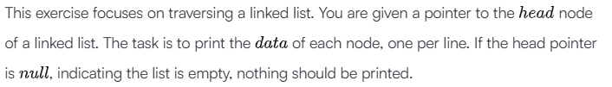
Ans.
import math
import os
import random
import re
import sys

class SinglyLinkedListNode:
def __init__(self, node_data):
self.data = node_data
self.next = None

class SinglyLinkedList:
def __init__(self):
self.head = None
self.tail = None

def insert_node(self, node_data):
node = SinglyLinkedListNode(node_data)

if not self.head:
self.head = node
else:
self.tail.next = node

self.tail = node
def printLinkedList(head):
current = head
while current is not None:
print(current.data)
current = current.next

if __name__ == '__main__':
llist_count = int(input())

llist = SinglyLinkedList()

for _ in range(llist_count):
llist_item = int(input())
llist.insert_node(llist_item)

printLinkedList(llist.head)

2.
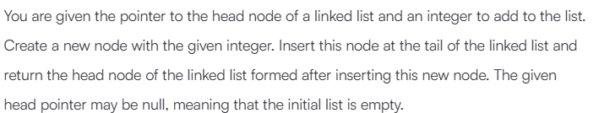
Ans.
import math
import os
import random
import re
import sys

class SinglyLinkedListNode:
def __init__(self, node_data):
self.data = node_data
self.next = None

class SinglyLinkedList:
def __init__(self):
self.head = None

def print_singly_linked_list(node, sep, fptr):
while node:
fptr.write(str(node.data))

node = node.next

if node:
fptr.write(sep)
def insertNodeAtTail(head, data):
new_node = SinglyLinkedListNode(data)
if head is None:
return new_node
current = head
while current.next is not None:
current = current.next
current.next = new_node

return head

if __name__ == '__main__':
fptr = open(os.environ['OUTPUT_PATH'], 'w')

llist_count = int(input())

llist = SinglyLinkedList()

for i in range(llist_count):
llist_item = int(input())
llist_head = insertNodeAtTail(llist.head, llist_item)
llist.head = llist_head

print_singly_linked_list(llist.head, '\n', fptr)
fptr.write('\n')

fptr.close()

3.
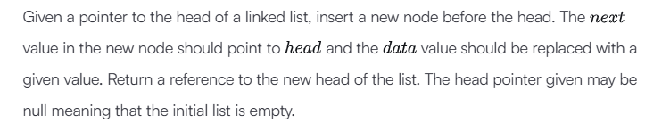
Ans.
import math
import os
import random
import re
import sys

class SinglyLinkedListNode:
def __init__(self, node_data):
self.data = node_data
self.next = None

class SinglyLinkedList:
def __init__(self):
self.head = None
self.tail = None

def print_singly_linked_list(node, sep, fptr):
while node:
fptr.write(str(node.data))

node = node.next

if node:
fptr.write(sep)
def insertNodeAtHead(llist, data):
new_node = SinglyLinkedListNode(data)
new_node.next = llist
return new_node

if __name__ == '__main__':
fptr = open(os.environ['OUTPUT_PATH'], 'w')

llist_count = int(input())

llist = SinglyLinkedList()

for _ in range(llist_count):
llist_item = int(input())
llist_head = insertNodeAtHead(llist.head, llist_item)
llist.head = llist_head

print_singly_linked_list(llist.head, '\n', fptr)
fptr.write('\n')

fptr.close()
4.
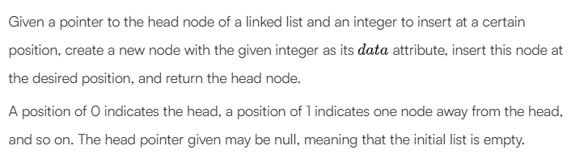
Ans.
import math
import os
import random
import re
import sys
class SinglyLinkedListNode:
def __init__(self, node_data):
self.data = node_data
self.next = None

class SinglyLinkedList:
def __init__(self):
self.head = None
self.tail = None

def insert_node(self, node_data):
node = SinglyLinkedListNode(node_data)

if not self.head:
self.head = node
else:
self.tail.next = node

self.tail = node

def print_singly_linked_list(node, sep, fptr):
while node:
fptr.write(str(node.data))

node = node.next

if node:
fptr.write(sep)
def insertNodeAtPosition(llist, data, position):
new_node = SinglyLinkedListNode(data)

if position == 0:
new_node.next = llist
return new_node

current = llist
for _ in range(position - 1):
current = current.next

new_node.next = current.next
current.next = new_node

return llist

if __name__ == '__main__':
fptr = open(os.environ['OUTPUT_PATH'], 'w')

llist_count = int(input())

llist = SinglyLinkedList()

for _ in range(llist_count):
llist_item = int(input())
llist.insert_node(llist_item)

data = int(input())

position = int(input())

llist_head = insertNodeAtPosition(llist.head, data, position)

print_singly_linked_list(llist_head, ' ', fptr)
fptr.write('\n')

fptr.close()
5.
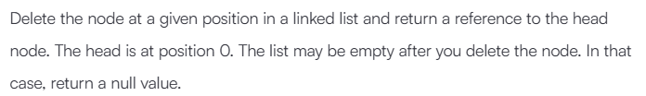
Ans.
import math
import os
import random
import re
import sys

class SinglyLinkedListNode:
def __init__(self, node_data):
self.data = node_data
self.next = None

class SinglyLinkedList:
def __init__(self):
self.head = None
self.tail = None

def insert_node(self, node_data):
node = SinglyLinkedListNode(node_data)

if not self.head:
self.head = node
else:
self.tail.next = node

self.tail = node

def print_singly_linked_list(node, sep, fptr):
while node:
fptr.write(str(node.data))

node = node.next

if node:
fptr.write(sep)
def deleteNode(llist, position):
if position == 0:
return llist.next

current = llist
for _ in range(position - 1):
current = current.next

current.next = current.next.next

return llist

if __name__ == '__main__':
fptr = open(os.environ['OUTPUT_PATH'], 'w')

llist_count = int(input())

llist = SinglyLinkedList()

for _ in range(llist_count):
llist_item = int(input())
llist.insert_node(llist_item)

position = int(input())

llist1 = deleteNode(llist.head, position)

print_singly_linked_list(llist1, ' ', fptr)
fptr.write('\n')

fptr.close()
6.

Ans.
import math
import os
import random
import re
import sys

class SinglyLinkedListNode:
def __init__(self, node_data):
self.data = node_data
self.next = None

class SinglyLinkedList:
def __init__(self):
self.head = None
self.tail = None

def insert_node(self, node_data):
node = SinglyLinkedListNode(node_data)

if not self.head:
self.head = node
else:
self.tail.next = node

self.tail = node

def print_singly_linked_list(node, sep):
while node:
print(node.data, end='')

node = node.next

if node:
print(sep, end='')
def reversePrint(llist):
stack = []

current = llist
while current:
stack.append(current.data)
current = current.next
while stack:
print(stack.pop())

if __name__ == '__main__':
tests = int(input())

for tests_itr in range(tests):
llist_count = int(input())

llist = SinglyLinkedList()

for _ in range(llist_count):
llist_item = int(input())
llist.insert_node(llist_item)

reversePrint(llist.head)
7.
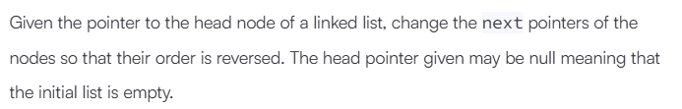
Ans.
import math
import os
import random
import re
import sys

class SinglyLinkedListNode:
def __init__(self, node_data):
self.data = node_data
self.next = None

class SinglyLinkedList:
def __init__(self):
self.head = None
self.tail = None

def insert_node(self, node_data):
node = SinglyLinkedListNode(node_data)

if not self.head:
self.head = node
else:
self.tail.next = node

self.tail = node

def print_singly_linked_list(node, sep, fptr):
while node:
fptr.write(str(node.data))

node = node.next

if node:
fptr.write(sep)
def reverse(llist):
prev = None
current = llist

while current:
next_node = current.next
current.next = prev
prev = current
current = next_node
return prev

if __name__ == '__main__':
fptr = open(os.environ['OUTPUT_PATH'], 'w')

tests = int(input())

for tests_itr in range(tests):
llist_count = int(input())

llist = SinglyLinkedList()

for _ in range(llist_count):
llist_item = int(input())
llist.insert_node(llist_item)

llist1 = reverse(llist.head)

print_singly_linked_list(llist1, ' ', fptr)
fptr.write('\n')

fptr.close()

8.
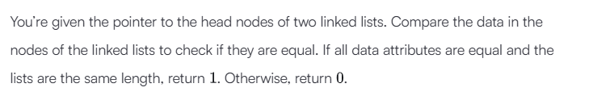
Ans.
import os
import sys

class SinglyLinkedListNode:
def __init__(self, node_data):
self.data = node_data
self.next = None

class SinglyLinkedList:
def __init__(self):
self.head = None
self.tail = None

def insert_node(self, node_data):
node = SinglyLinkedListNode(node_data)

if not self.head:
self.head = node
else:
self.tail.next = node

self.tail = node

def print_singly_linked_list(node, sep, fptr):
while node:
fptr.write(str(node.data))

node = node.next

if node:
fptr.write(sep)
def compare_lists(llist1, llist2):
while llist1 and llist2:
if llist1.data != llist2.data:
return 0
llist1 = llist1.next
llist2 = llist2.next

if llist1 is None and llist2 is None:
return 1
else:
return 0

if __name__ == '__main__':
fptr = open(os.environ['OUTPUT_PATH'], 'w')

tests = int(input())

for tests_itr in range(tests):
llist1_count = int(input())

llist1 = SinglyLinkedList()

for _ in range(llist1_count):
llist1_item = int(input())
llist1.insert_node(llist1_item)

llist2_count = int(input())

llist2 = SinglyLinkedList()

for _ in range(llist2_count):
llist2_item = int(input())
llist2.insert_node(llist2_item)
result = compare_lists(llist1.head, llist2.head)
fptr.write(str(int(result)) + '\n')

fptr.close()
9.

Ans.
import math
import os
import random
import re
import sys

class SinglyLinkedListNode:
def __init__(self, node_data):
self.data = node_data
self.next = None

class SinglyLinkedList:
def __init__(self):
self.head = None
self.tail = None

def insert_node(self, node_data):
node = SinglyLinkedListNode(node_data)

if not self.head:
self.head = node
else:
self.tail.next = node

self.tail = node

def print_singly_linked_list(node, sep, fptr):
while node:
fptr.write(str(node.data))

node = node.next

if node:
fptr.write(sep)
def mergeLists(head1, head2):
if not head1:
return head2
if not head2:
return head1

if head1.data <= head2.data:
merged_head = head1
head1 = head1.next
else:
merged_head = head2
head2 = head2.next

current = merged_head

while head1 and head2:
if head1.data <= head2.data:
current.next = head1
head1 = head1.next
else:
current.next = head2
head2 = head2.next
current = current.next

if head1:
current.next = head1
elif head2:
current.next = head2

return merged_head

if __name__ == '__main__':
fptr = open(os.environ['OUTPUT_PATH'], 'w')

tests = int(input())

for tests_itr in range(tests):
llist1_count = int(input())

llist1 = SinglyLinkedList()

for _ in range(llist1_count):
llist1_item = int(input())
llist1.insert_node(llist1_item)

llist2_count = int(input())

llist2 = SinglyLinkedList()

for _ in range(llist2_count):
llist2_item = int(input())
llist2.insert_node(llist2_item)

llist3 = mergeLists(llist1.head, llist2.head)
print_singly_linked_list(llist3, ' ', fptr)
fptr.write('\n')
fptr.close()

10.
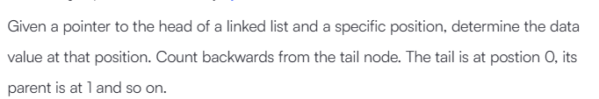
Ans.
import math
import os
import random
import re
import sys

class SinglyLinkedListNode:
def __init__(self, node_data):
self.data = node_data
self.next = None

class SinglyLinkedList:
def __init__(self):
self.head = None
self.tail = None

def insert_node(self, node_data):
node = SinglyLinkedListNode(node_data)

if not self.head:
self.head = node
else:
self.tail.next = node

self.tail = node

def print_singly_linked_list(node, sep, fptr):
while node:
fptr.write(str(node.data))

node = node.next

if node:
fptr.write(sep)
def getNode(llist, positionFromTail):
fast = llist
slow = llist

for _ in range(positionFromTail):
if fast:
fast = fast.next

while fast and fast.next:
fast = fast.next
slow = slow.next

return slow.data
# Write your code here

if __name__ == '__main__':
fptr = open(os.environ['OUTPUT_PATH'], 'w')

tests = int(input())

for tests_itr in range(tests):
llist_count = int(input())

llist = SinglyLinkedList()

for _ in range(llist_count):
llist_item = int(input())
llist.insert_node(llist_item)
position = int(input())
result = getNode(llist.head, position)

fptr.write(str(result) + '\n')
fptr.close()
11.
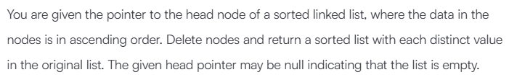
Ans.
import math
import os
import random
import re
import sys

class SinglyLinkedListNode:
def __init__(self, node_data):
self.data = node_data
self.next = None

class SinglyLinkedList:
def __init__(self):
self.head = None
self.tail = None

def insert_node(self, node_data):
node = SinglyLinkedListNode(node_data)

if not self.head:
self.head = node
else:
self.tail.next = node

self.tail = node

def print_singly_linked_list(node, sep, fptr):
while node:
fptr.write(str(node.data))

node = node.next

if node:
fptr.write(sep)
def removeDuplicates(llist):
if llist is None:
return None

current = llist
while current.next:
if current.data == current.next.data:
current.next = current.next.next
else:
current = current.next

return llist

if __name__ == '__main__':
fptr = open(os.environ['OUTPUT_PATH'], 'w')

t = int(input())

for t_itr in range(t):
llist_count = int(input())

llist = SinglyLinkedList()

for _ in range(llist_count):
llist_item = int(input())
llist.insert_node(llist_item)

llist1 = removeDuplicates(llist.head)

print_singly_linked_list(llist1, ' ', fptr)
fptr.write('\n')

fptr.close()

12.
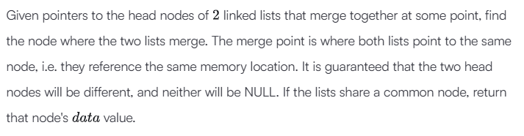
Ans.
import math
import os
import random
import re
import sys

class SinglyLinkedListNode:
def __init__(self, node_data):
self.data = node_data
self.next = None

class SinglyLinkedList:
def __init__(self):
self.head = None
self.tail = None

def insert_node(self, node_data):
node = SinglyLinkedListNode(node_data)

if not self.head:
self.head = node
else:
self.tail.next = node

self.tail = node

def print_singly_linked_list(node, sep, fptr):
while node:
fptr.write(str(node.data))

node = node.next

if node:
fptr.write(sep)
def findMergeNode(head1, head2):
ptr1 = head1
ptr2 = head2

while ptr1 != ptr2:
if ptr1 is None:
ptr1 = head2
else:
ptr1 = ptr1.next

if ptr2 is None:
ptr2 = head1
else:
ptr2 = ptr2.next

return ptr1.data

if __name__ == '__main__':
fptr = open(os.environ['OUTPUT_PATH'], 'w')

tests = int(input())

for tests_itr in range(tests):
index = int(input())

llist1_count = int(input())

llist1 = SinglyLinkedList()

for _ in range(llist1_count):
llist1_item = int(input())
llist1.insert_node(llist1_item)

llist2_count = int(input())

llist2 = SinglyLinkedList()

for _ in range(llist2_count):
llist2_item = int(input())
llist2.insert_node(llist2_item)

ptr1 = llist1.head;
ptr2 = llist2.head;

for i in range(llist1_count):
if i < index:
ptr1 = ptr1.next

for i in range(llist2_count):
if i != llist2_count-1:
ptr2 = ptr2.next
ptr2.next = ptr1
result = findMergeNode(llist1.head, llist2.head)

fptr.write(str(result) + '\n')
fptr.close()
13.

Ans.
import math
import os
import random
import re
import sys

class DoublyLinkedListNode:
def __init__(self, node_data):
self.data = node_data
self.next = None
self.prev = None

class DoublyLinkedList:
def __init__(self):
self.head = None
self.tail = None

def insert_node(self, node_data):
node = DoublyLinkedListNode(node_data)

if not self.head:
self.head = node
else:
self.tail.next = node
node.prev = self.tail

self.tail = node

def print_doubly_linked_list(node, sep, fptr):
while node:
fptr.write(str(node.data))

node = node.next

if node:
fptr.write(sep)
def sortedInsert(llist, data):
new_node = DoublyLinkedListNode(data)

if llist is None:
return new_node

if data <= llist.data:
new_node.next = llist
llist.prev = new_node
return new_node

current = llist
while current.next and current.next.data < data:
current = current.next

if current.next is None:
current.next = new_node
new_node.prev = current
else:
new_node.next = current.next
new_node.prev = current
current.next.prev = new_node
current.next = new_node

return llist
if __name__ == '__main__':
fptr = open(os.environ['OUTPUT_PATH'], 'w')

t = int(input())

for t_itr in range(t):
llist_count = int(input())

llist = DoublyLinkedList()

for _ in range(llist_count):
llist_item = int(input())
llist.insert_node(llist_item)

data = int(input())

llist1 = sortedInsert(llist.head, data)

print_doubly_linked_list(llist1, ' ', fptr)
fptr.write('\n')

fptr.close()

14.
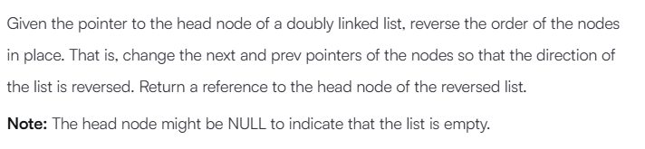
Ans.
import math
import os
import random
import re
import sys

class DoublyLinkedListNode:
def __init__(self, node_data):
self.data = node_data
self.next = None
self.prev = None

class DoublyLinkedList:
def __init__(self):
self.head = None
self.tail = None

def insert_node(self, node_data):
node = DoublyLinkedListNode(node_data)

if not self.head:
self.head = node
else:
self.tail.next = node
node.prev = self.tail

self.tail = node

def print_doubly_linked_list(node, sep, fptr):
while node:
fptr.write(str(node.data))

node = node.next

if node:
fptr.write(sep)
def reverse(llist):
if not llist:
return None

current = llist
new_head = None

while current:
temp = current.prev
current.prev = current.next
current.next = temp

new_head = current
current = current.prev

return new_head
if __name__ == '__main__':
fptr = open(os.environ['OUTPUT_PATH'], 'w')

t = int(input())

for t_itr in range(t):
llist_count = int(input())

llist = DoublyLinkedList()

for _ in range(llist_count):
llist_item = int(input())
llist.insert_node(llist_item)

llist1 = reverse(llist.head)

print_doubly_linked_list(llist1, ' ', fptr)
fptr.write('\n')

fptr.close()

